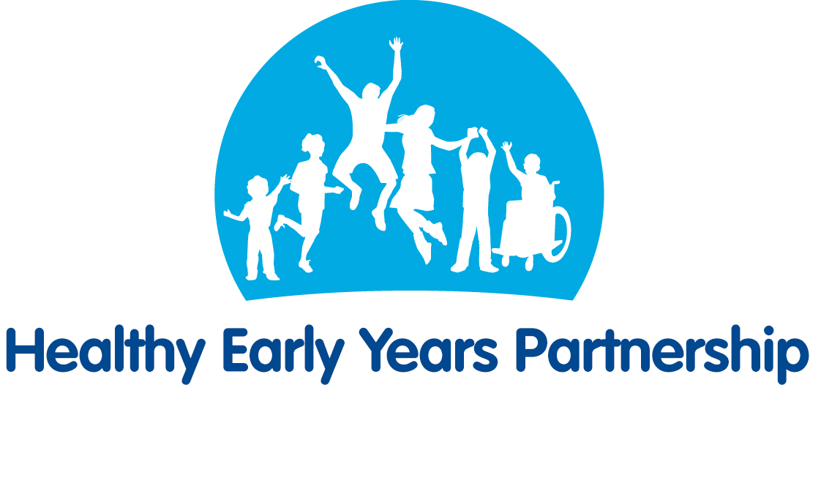
Vaccinations and Immunisations (Baby) – Top Tips for Parents/Carers
All information taken from the NHS website. For more information see:
https://www.nhs.uk/start4life/baby/vaccinations-and-immunisations-baby/

Vaccinations & Immunisations
- One of the best ways to protect your baby against diseases like measles, rubella, tetanus and meningitis, is through immunisations. Your baby needs his or her first injections at eight weeks, then 12 weeks, 16 weeks and one year.
- Vaccinations are offered free of charge in the UK - just book your appointments with your GP. Remember, as well as protecting your own baby, you're also protecting other babies and children by preventing the spread of disease.

Vaccination Schedule
- 8 weeks:
  - 6-in-1 vaccine
  - PCV (Pneumococcal) vaccine
  - RV (Rotavirus) vaccine
  - MenB vaccine
- 12 weeks:
  - 6-in-1 vaccine – 2nd dose
  - RV (Rotavirus) vaccine – 2nd dose
- 16 weeks:
  - 6-in-1 vaccine – 3rd dose
  - PCV (Pneumococcal) vaccine – 2nd dose
  - MenB vaccine – 2nd dose
- 1 year:
  - Hib/MenC vaccine , given as a single jab containing vaccines against meningitis C (1st dose) and Hib (4th dose)
  - MMR vaccine (Measles, mumps and rubella), given as a single jab
  - PCV (Pneumococcal) – 3rd dose
  - MenB vaccine – 3rd dose

Quick guide to your baby’s vaccinations
- 6-in-1 protects against:
  - Diphtheria – a highly contagious bacterial infection, spread by coughs and sneezes, or close contact with someone with diphtheria.
  - Hepatitis B – an infection of the liver caused by a virus that is spread through blood and bodily fluids.
  - Hib (Haemophilus influenza type b) – a bacteria that can cause several serious conditions including meningitis, septicaemia (a kind of blood poisoning) and cellulitis.
  - Polio – a viral infection that can cause paralysis.
  - Tetanus – a bacteria that can enter the body through a wound like a cut or scrape.
  - Whooping cough (pertussis) – highly contagious bacterial infection of the lungs and airways.
- PCV or 'pneumo jab' protects against pneumococcal infections that can lead to pneumonia, septicaemia and meningitis.
- RV protects against rotavirus infection that can cause diarrhoea and vomiting.
- MenB protects against meningitis and septicaemia.
- Hib/MenC protects against haemophilus influenza (a bacterium that can cause different serious illnesses) and meningitis C.
- MMR protects against measles, mumps and rubella (German measles).

The Red Book
- Your baby's Personal Child Health Record is also known as the 'red book' or PCHR. It's used to record your child's weight and height, vaccinations they've been given, and other important health information.
- You can also add information yourself - it's a great way of keeping track of your child's progress. Remember to take it with you when your baby has appointments at the clinic, GP or hospital.

Health & Development Checks
- Your baby's health checks are very important – they are an opportunity to check that your baby is developing properly.
- They are usually carried out by your health visitor either at home, in your GP surgery, baby clinic or children's centre. These development checks are also a good opportunity for you to raise any concerns you might have.
- Your baby's very first health check takes place shortly after they are born, and they’ll continue until your child is two to two-and-a-half years old.

