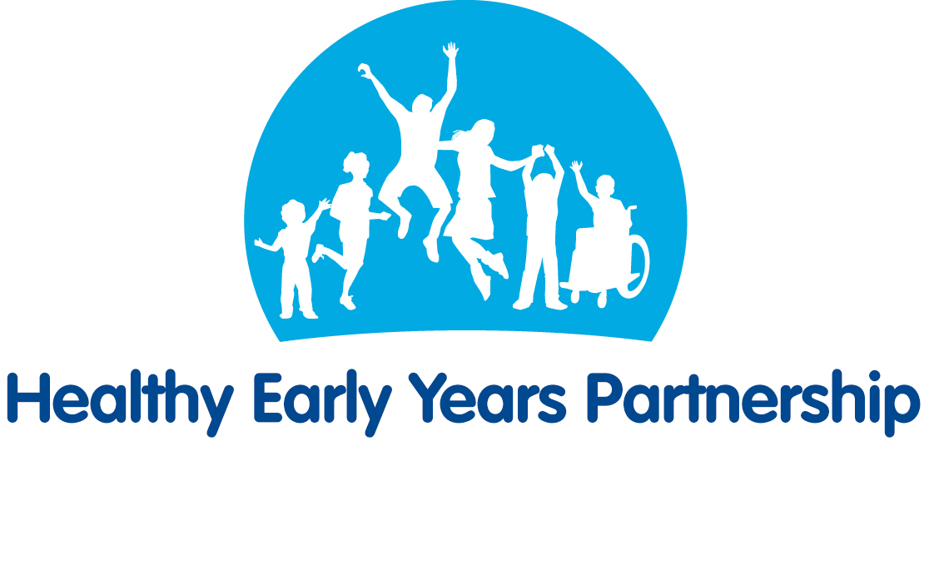
Vaccinations & Immunisations 1 yr + – Top Tips for Parents/Carers
All information taken from the NHS website. For more information see:
https://www.nhs.uk/start4life/toddler/vaccinations-and-immunisations-toddler/

Vaccinations & Immunisations
- One of the best ways to protect your child against diseases like measles, rubella, tetanus and meningitis, is through immunisations.
- Vaccinations are offered free of charge in the UK, just book your appointments with your GP.
- Remember, as well as protecting your own child, you're also protecting others by preventing the spread of disease.

Vaccination Schedule
- 1 year:
  - Hib/MenC vaccine , given as a single jab containing vaccines against meningitis C (1st dose) and Hib (4th dose)
  - MMR vaccine (measles, mumps and rubella), given as a single jab
  - PCV (Pneumococcal) – 3rd dose
  - MenB vaccine – 3rd dose
- 2-8 years (including children in reception class and school years 1 to 4):
  - Children's flu vaccine (annual)
- 3 years and 4 months:
  - MMR vaccine (Measles, mumps and rubella) – 2nd dose
  - 4-in-1 pre-school booster, given as a single jab (diphtheria, tetanus, whooping cough or pertussis, and polio)

Quick guide to your baby’s vaccinations
- PCV or 'pneumo jab' protects against pneumococcal infections that can lead to pneumonia, septicaemia and meningitis.
- MenB protects against meningitis and septicaemia
- Hib/MenC protects against haemophilus influenza (a bacterium that can cause serious different illnesses) and meningitis C
- MMR protects against measles, mumps and rubella (German measles).
- 4-in-1 boosts protection against diphtheria, tetanus, whooping cough and polio
- Flu given as a nasal spray, protects your child against getting the flu

The Red Book
- Your baby's Personal Child Health Record is also known as the 'red book' or PCHR. It's used to record your child's weight and height, vaccinations they've been given, and other important health information.
- You can also add information yourself - it's a great way of keeping track of your child's progress. Remember to take it with you when your baby has appointments at the clinic, GP or hospital.

Health & Development Checks
- Your baby's health checks are very important – they are an opportunity to check that your baby is developing properly.
- They are usually carried out by your health visitor either at home, in your GP surgery, baby clinic or children's centre. These development checks are also a good opportunity for you to raise any concerns you might have.
- Your baby's very first health check takes place shortly after they are born, and they’ll continue until your child is two to two-and-a-half years old.

Useful Websites
- NHS Vaccinations - https://www.nhs.uk/conditions/vaccinations/
- NHS Why vaccinate your kids? - https://www.nhs.uk/conditions/vaccinations/reasons-to-have-your-child-vaccinated/
- NHS Vaccination tips for parents - https://www.nhs.uk/conditions/vaccinations/vaccination-appointment-tips-for-parents/
- NHS personalised vaccination planner - https://www.nhs.uk/Tools/Pages/NHSvaccinationplanner.aspx
- The complete routine immunisation schedule - https://www.gov.uk/government/publications/the-complete-routine-immunisation-schedule

