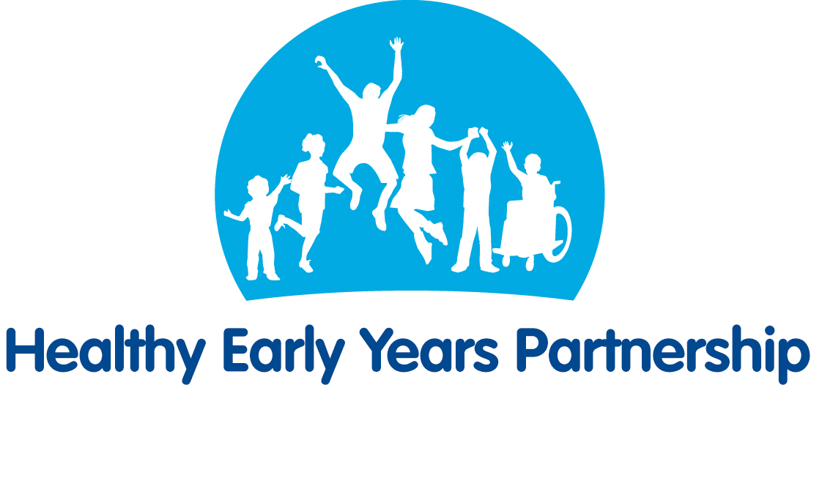
Oral Health – Top Tips for Parents/Carers
All information taken from the NHS website. For more information see:
http://www.nhs.uk/Livewell/dentalhealth/Pages/Careofkidsteeth.aspx
http://www.nhs.uk/Livewell/dentalhealth/Pages/Goodhabitskids.aspx

Toothpaste Tips
- Start brushing your baby's teeth with fluoride toothpaste as soon as the first milk tooth breaks through (usually at around six months, but it can be earlier or later). It's important to use a fluoride paste, as this helps to prevent and control tooth decay.
- There's no need to buy special "children's toothpaste" brands. In fact, some of them don’t have enough fluoride in them to help prevent tooth decay.
- Children from the age of seven can use family toothpaste, as long as it contains 1,350-1,500 parts per million (ppm) fluoride. Check the toothpaste packet if you're not sure, or ask your dentist.
- Children up to the age of six who don't have tooth decay can use a lower-strength toothpaste, but make sure it contains at least 1,000ppm fluoride.
- Make sure children don't eat or lick toothpaste from the tube.
- Below the age of three years, children should use just a smear of toothpaste.
- Children aged three to six should use a pea-sized blob of toothpaste.

Toothbrushing Tips
- Start brushing your baby's teeth with fluoride toothpaste as soon as the first milk tooth breaks through (usually at around six months, but it can be earlier or later). It's important to use a fluoride paste, as this helps to prevent and control tooth decay.
- Brush your child's teeth for about two minutes twice a day: once just before bedtime and at least one other time during the day.
- Encourage them to spit out excess toothpaste, but not to rinse with lots of water. Rinsing with water after tooth brushing will wash away the fluoride and make it less effective.
- Supervise tooth brushing until your child is seven or eight years old, either by brushing their teeth yourself or, if they brush their own teeth, by watching how they do it. From the age of seven or eight, they should be able to brush their own teeth, but it's still a good idea to watch them now and again to make sure they brush properly and for about two minutes.

Taking your child to the dentist
- NHS dental care for children is free.
- Take your child to the dentist when their first milk teeth appear. This is so they become familiar with the environment and get to know the dentist. The dentist can help prevent decay and identify any oral health problems at an early stage. Just opening up the child's mouth for the dentist to take a look at is useful practise for the future.
- When you visit the dentist, be positive about it and make the trip fun. This will stop your child worrying about future visits.
- Take your child for regular dental check-ups as advised by the dentist.

Flouride Varnish and Fissure Sealents
- Fluoride varnish can be applied to both baby teeth and adult teeth. It involves painting a varnish that contains high levels of fluoride on to the surface of the tooth every six months to prevent decay. It works by strengthening tooth enamel, making it more resistant to decay.
- From the age of three, children should be offered fluoride varnish application at least twice a year. Younger children may also be offered this treatment if your dentist thinks they need it.
- Fissure sealants can be done once your child's permanent back teeth have started to come through (usually at the age of about six or seven) to protect them from decay. This is where the chewing surfaces of the back teeth are covered with a special thin plastic coating to keep germs and food particles out of the grooves. The sealant can last for as long as 5 to 10 years.
- Ask your dentist about fluoride varnish or fissure sealing.

Looking after teeth – eating and drinking

Sweets: Most children want sweets, but you can help to prevent problems by making sure they don't have a large amount or very often, and particularly not before bed, when saliva flow lessens. Try not to give sweets or sweet drinks as rewards.

Snacks: The best snacks are fruit and raw vegetables. Try tangerines, bananas, pieces of cucumber or carrot sticks. Other good snacks include toast, rice cakes and plain popcorn. Dried fruit is high in sugar and can be bad for teeth, so only ever give it to children with meals – for instance, as a dessert – and never as a snack between meals. The NHS Change4Life website has tips and ideas for cutting down on sugary foods and drinks.

Fizzy Drinks: No. Fizzy drinks can contain large amounts of sugar, which will increase the risk of tooth decay. Fizzy drinks (both those containing sugar and sugar-free or "diet" versions) also contain acids that can erode the outer surface of the tooth.

Drinks: The best drinks for children over one year old are plain still water or plain milk. Your child should have full-fat milk (whole milk) from the age of 12 months to two years. Semi-skimmed milk can be introduced from the age of two, as long as your child is a good eater and growing well for their age. Skimmed milk can be given to children aged five and over. Cow's milk is not suitable as a drink for babies under 12 months of age.

Fruit Juice and Smoothies: Even unsweetened juices and smoothies contain sugars and acids, so although they can contribute towards their 5 A DAY, restrict your child to no more than one small glass (about 150ml) of fruit juice or smoothie each day and only at mealtimes. Also, be aware that unsweetened 100% fruit juice, vegetable juice and smoothies can only ever count as a maximum of one portion of their 5 A DAY. For example, if they have two glasses of fruit juice and a smoothie in one day, that still only counts as one portion. If your child is thirsty, it's better to give them water than to encourage a taste for sweet drinks. Try to avoid giving babies fruit-flavoured "baby juices", and never give them in feeding bottles. Fruit juice should not be given to babies under six months.

Milk at bedtime: Teeth are at most risk at night because there is less saliva in the mouth to protect them. Water is the best drink to give at bedtime, but if you do give milk, don't add anything to it. Chocolate-flavoured drinks and milkshake powder usually contain sugars, which will increase the risk of decay.

Medicines: Yes. Always ask if a sugar-free medicine is available and remind your doctor about this if you're being given a prescription for your child. This is especially important if your child is taking long-term medication.
Bottles: Your child should begin moving off the bottle and on to a free-flow feeder cup at six months. Try to get them off bottles completely by the age of one, because the teats and spouts encourage children to suck for long periods of time, meaning the drinks that cause tooth decay stay in contact with your child's teeth for a long time.

Sippy Cups: There's no need for a child to use a sippy cup. They're similar to a bottle in that they require the child to suck to make them work. A free-flow feeder cup is better, as it doesn't have valves and the flow of liquid is unrestricted. This means that children learn to drink normally rather than by sucking.

Dummy or Thumb Sucking: No, but they will encourage an open bite, which is when teeth move to make space for the dummy or thumb. They may also affect speech development. That's why you should avoid using dummies after 12 months of age. Thumb sucking won't cause permanent problems, as long as the habit stops by the time your child gets their second teeth, but it can be a hard habit to break. Discourage your children from talking or making sounds with their thumb or a dummy in their mouth, and don't dip dummies in anything sweet, such as sugar or jam.

