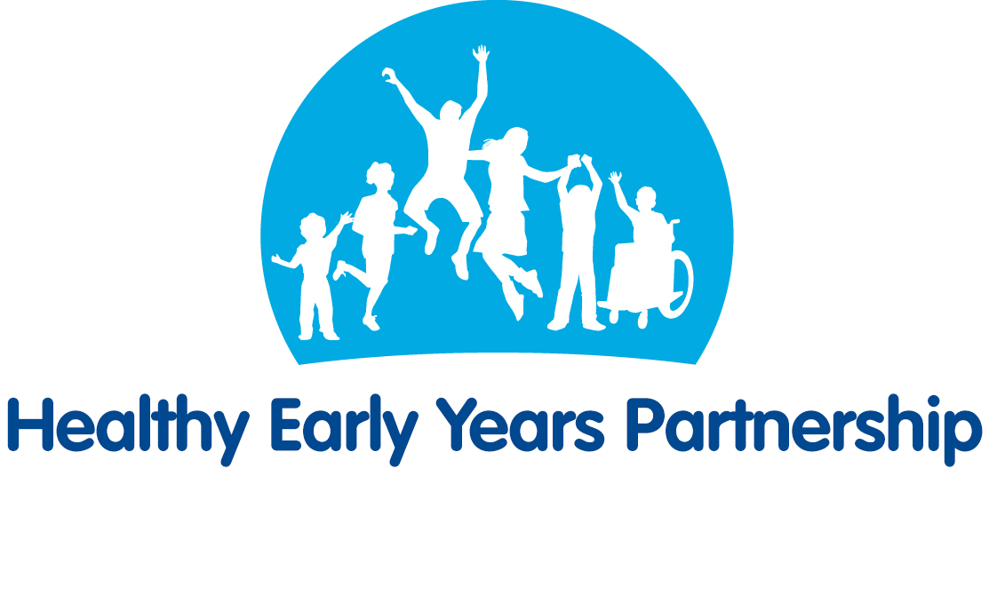**Healthy Eating (From 12 months) – Top Tips for Parents/Carers**

All information taken from the NHS website. For more information see:

<https://www.nhs.uk/start4life/toddler/healthy-foods/>

**Drinks**

* Plain water is the best drink at mealtimes. Avoid sugary drinks as these can cause tooth decay. If you give your child fruit juice, dilute it with water first.
* For your baby's main milk drink, you can offer pasteurised whole (full-fat) cows' milk, or goats' or sheep's milk.
* From two years, if your toddler is a good eater and growing well, they can have semi-skimmed milk.
* From five years old, you can give 1% fat or skimmed milk.
* By the time your baby is 12 months old, they should have stopped using bottles with teats altogether. Your baby should be drinking from an open or a free-flow cup, this helps them learn to sip rather than suck drinks (which is better for their teeth).

**Vitamins**

* Keep giving your baby daily vitamin supplements containing vitamins A, C and D until they are five years old.
* If you feed your baby infant formula, they don't need vitamin drops as long as they're having 500ml (about a pint) or more of formula a day.
* If you're under 18, or on benefits, you may be entitled to free Healthy Start vitamin drops and food vouchers. In some areas, Healthy Start vitamins are free to all families – ask your health visitor if they're free where you live.

**Fruits & Vegetables**

* Fruit and vegetables contain lots of vitamins, minerals and fibre. It's good to introduce lots of different types from an early age, whether fresh, frozen, canned or dried, so your baby can enjoy new textures and flavours. Try to make sure fruit and vegetables are included in every meal.
* Dried fruit, such as raisins, should be given to your toddler with meals, rather than as a snack in between, as the sugar they contain can cause tooth decay.
* Different fruit and vegetables contain different vitamins and minerals, so the more different types your toddler eats the better.
* Don't worry if they'll only eat one or two types at first. Keep offering them small amounts of other fruit and vegetables so they can learn to like different tastes.
* Some children don't like cooked vegetables but will nibble on raw vegetables while you’re preparing a meal.

**Bread, rice, potatoes, pasta and other starchy foods**

* Starchy foods, such as bread, breakfast cereals, potatoes, yams, rice, couscous, pasta and chapattis provide energy, nutrients and some fibre.
* You can give your child wholegrain foods, such as wholemeal bread, pasta and brown rice. However, it's not a good idea to only give wholegrain starchy foods to under-twos.
* Wholegrain foods can be high in fibre and they may fill your child up before they've taken in the calories and nutrients they need. After age two you can gradually introduce more wholegrain foods.

**Milk and Dairy Products**

* Breast milk is the only food or drink babies need in the first six months of their life. It's best to carry on breastfeeding alongside an increasingly varied diet once you introduce solid foods.
* Infant formula is the only suitable alternative to breast milk in the first 12 months of your baby's life.
* Whole cows' milk can be given as a main drink from the age of one.
* Whole milk and full-fat dairy products are a good source of calcium, which helps your child to develop strong bones and teeth. They also contain vitamin A, which helps the body resist infections and is needed for healthy skin and eyes.
* Try to give your child at least 350ml (12oz) of milk a day or two servings of foods made from milk, such as cheese, yoghurt or fromage frais.
* Semi-skimmed milk can be introduced from the age of two, provided your child is a good eater and growing well for their age. Skimmed or 1% fat milk doesn’t contain enough fat so isn’t recommended for children under five. You can use them in cooking from the age of one though.
* You can give your child unsweetened calcium-fortified milk alternatives, such as soya, almond and oat drinks, from the age of one as part of a healthy balanced diet. Toddlers and young children under the age of five shouldn't have rice drinks, because of the levels of arsenic they contain.
* If your child has an allergy or intolerance to milk, talk to your health visitor or GP. They can advise you on suitable milk alternatives.

**Beans, pulses, fish, eggs, meat and other proteins**

* Young children need protein and iron to grow and develop. Try to give your toddler one or two portions from this group each day.
* Beans, pulses, fish, eggs, foods made from pulses (such as tofu, hummus and soya mince) and meat are excellent sources of protein and iron.
* Nuts also contain protein but whole nuts, including peanuts, shouldn't be given to children under five in case they choke.
* It's recommended that boys have no more than four portions of oily fish (such as mackerel, salmon and sardines) a week, and girls no more than two portions a week. This is because oily fish can contain low levels of pollutants that can build up in the body.
* Remember, don't stop feeding your child oily fish because the health benefits are greater than the risks, as long as they don't eat more than the recommended amounts.

**Helping your child get enough iron**

* Iron is essential for your child's health. It comes in two forms:
* the iron found in meat and fish, which is easily absorbed by the body
* iron from plant foods, which is not as easy for the body to absorb
* If your child doesn't eat meat or fish, they will get enough iron if you give them plenty of other iron-rich foods, such as fortified breakfast cereals, dark green vegetables, broad beans and lentils.
* If young children fill up on milk it makes it difficult for them to get the calories and nutrients they need from a varied diet. These children are more likely to lack iron, which can lead to iron-deficiency anaemia. This can affect your child's physical and mental development.

**Foods containing fat**

* Young children, especially those under the age of two, need the energy provided by fat. There are also some vitamins that are only found in fats. This is why foods like whole milk, yoghurt, cheese and oily fish are so important.
* Once your child is two, you can gradually introduce lower-fat dairy products and cut down on fat in other foods – providing your child is a good eater and is growing well. By the time your child is five they can eat a healthy low-fat diet like the one recommended for adults.
* Keep an eye on the amount of fat (particularly saturated fats) in the food your family eats. Try to keep it to a minimum. The following tips will help you reduce the amount of fat in your family's meals:
  + Grill or bake foods instead of frying them
  + During cooking, skim the fat off meat dishes such as mince or curry
  + Buy leaner cuts of meat and lower-fat meat products, such as lower-fat sausages and burgers
  + Take the skin off poultry
  + Reduce the amount of meat you put in stews and casseroles. Make up the difference with lentils, split peas or soaked dried beans
* For children over two, use lower-fat dairy products, such as low-fat spreads and reduced-fat cheeses
* Use as little cooking oil as possible. Choose one that's high in mono- or polyunsaturates, such as rapeseed, soya or olive oil. In the UK, oil labelled 'vegetable oil' is often actually rapeseed oil

**Foods containing sugar**

* Brushing your child's teeth regularly and visits to the dentist are essential to help keep your child's teeth healthy. It's also important to keep the amount of added sugar they have to a minimum. Added sugar is found in fizzy drinks, juice drinks, sweets, cakes and jam.
* It's best to offer your toddler water or whole milk to drink. Semi-skimmed milk can be introduced once they are two years old. You can also offer diluted fruit juice (one part juice to 10 parts water) served with meals. Serving it with a meal helps to reduce the risk of tooth decay.
* From age five, it's OK to give your child undiluted fruit juice or smoothies, but stick to no more than one glass (about 150ml) a day served with a meal.
* The sugar in raisins and other dried fruits can cause tooth decay. It's best to give these to your toddler with meals rather than as a snack in between.

**Foods containing salt**

* There's no need to add salt to your child's food. Most foods already contain enough salt. Too much salt can give your child a taste for salty foods and contribute to high blood pressure in later life.
* Your whole family will benefit if you gradually reduce the amount of salt in your cooking. Try to limit the amount of salty foods your child has, and always check food labels.

**Healthy snacks for toddlers**

You could try:

* raw vegetable sticks, such as cucumber and carrots
* a plain yoghurt with a sliced banana in it
* a slice of toast with cheese spread, hummus or a slice of ham
* some crackers, breadsticks or unsalted rice cakes with cheese
* a bowl of cereal with milk
* a piece of fruit

**Fussy Eating**

* It's natural to worry whether your child is getting enough food if they refuse to eat sometimes.
* But it's perfectly normal for toddlers to refuse to eat or even taste new foods.
* The trick is not to worry about what your child eats in a day or if they don't eat everything at mealtimes. It's more helpful to think about what they eat over a week.
* If your child is active and gaining weight, and they seem well, then they're getting enough to eat.
* As long as your child eats some food from the 4 main food groups (fruit and vegetables; potatoes, bread, rice, pasta and other starchy carbohydrates; dairy or dairy alternatives; and beans, pulses, fish, eggs, meat and other proteins) you don't need to worry.
* Gradually introduce other foods and keep going back to the foods your child didn't like before. Children's tastes change. One day they'll hate something, but a month later they may love it.
* Keep offering a variety of foods – it may take lots of attempts before your child accepts some foods.
* Give your child the same food as the rest of the family, but remember not to add salt to your child's food. Check the label of any food product you use to make family meals.
* The best way for your child to learn to eat and enjoy new foods is to copy you. Try to eat with them as often as you can.
* Give small portions and praise your child for eating, even if they only eat a little.
* If your child rejects the food, don't force them to eat it. Just take the food away without saying anything. Try to stay calm, even if it's very frustrating. Try the food again another time.
* Don't leave meals until your child is too hungry or tired to eat.
* Your child may be a slow eater, so be patient.
* Don't give your child too many snacks between meals – 2 healthy snacks a day is plenty.
* It's best not to use food as a reward. Your child may start to think of sweets as nice and vegetables as nasty. Instead, reward them with a trip to the park or promise to play a game with them.
* Make mealtimes enjoyable and not just about eating. Sit down and chat about other things.
* If you know any other children of the same age who are good eaters, ask them round for tea. But don't talk too much about how good the other children are.
* Ask an adult that your child likes and looks up to to eat with you. Sometimes a child will eat for someone else, such as a grandparent, without any fuss.
* Changing how you serve a food may make it more appealing. For example, your child might refuse cooked carrots but enjoy raw grated carrot.